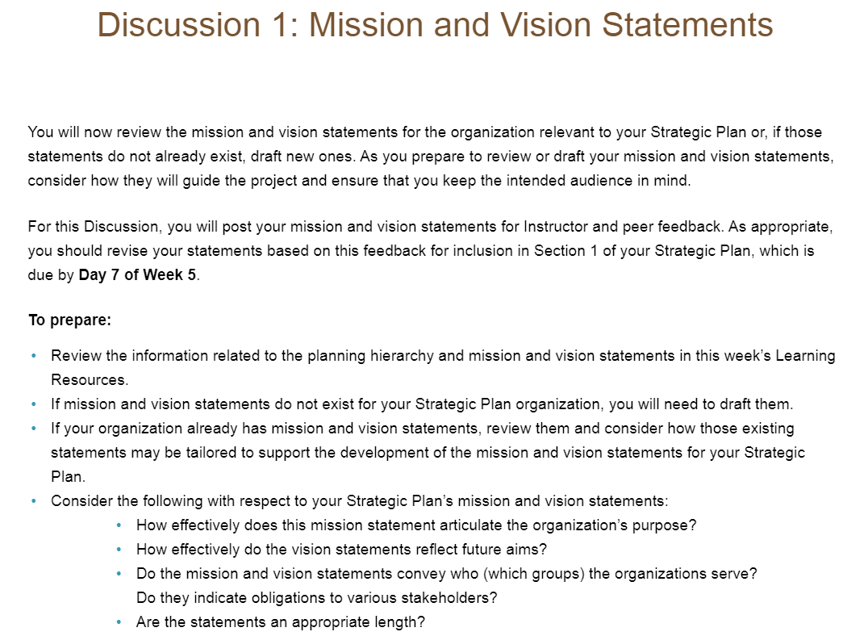
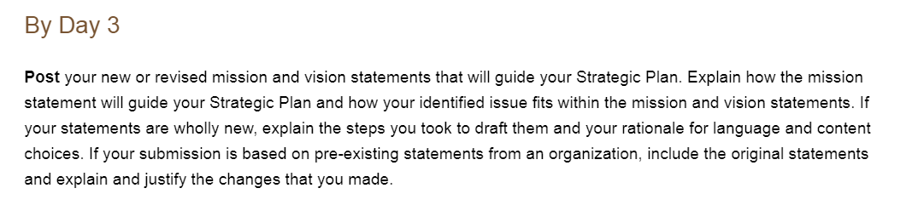
My Strategic Plan project: Separate Hospice and Palliative Care to two different departments to increase organization’s revenue.
Organization: Kaiser Permanente
